**GLASS CUTTING, BEVELING AND SALE MANAGEMENT SYSTEM**

**GROUP MEMBERS:**

**Maaz Sabahuddin [02-134171-131]**

**Muhammad Shahrukh Mahmood [02-134171-119]**

**Syed Shamekh Hussain [02-134171-120]**

**Azka Khan [02-134171-039]**

**A Project Report submitted for**

**OBJECT ORIENTED PROGRAMMING PROJECT**



**Department of Computer Science**

**Bahria University, Karachi Campus**

**BS (CS) – 2: SECTION: A**

**FALL 2017**

**TABLE OF CONTENTS:**

**Introduction:** **…………………………………………………………**

**Problem Statement: ……………………………………………..**

**UML Diagram: ………………………………………………………**

**Screen Shots: ……………………………………………………....INTRODUCTION:**

Glass manufacturing has become mature business in the developing countries of the world. Like other businesses, glass manufacturers are also looking for ways to make thing easier. This is a great ERP Solution information for glass manufacturers. Beveled glass is usually made by taking thick glass and creating an angled surface cut (bevel) around the entire periphery. Bevels act as prisms in the sunlight creating an interesting color diffraction. There are many types of glass some of them are as follows:

**TEMPERED GLASS:**

This product is used most often for shelves, some fire places and table tops. Tempered Glass breaks into small pieces when broken and usually cracks.

**ANNEALED GLASS:**

Often used in small pieces. This product is not considered a safety glass. Annealed Glass doesn’t shatter into small pieces. If broken, the piece will crack into large shards. Maximum annealed glass size is 28x28.For pieces larger then this please select Tempered Glass.

**MIRROR GLASS:**

This product is used to replace any mirror. Mirrors are not tempered and if broken will break into large shards.

**CERAMIC GLASS:**

These products are made to withstand very high temperature and are often used in woodstoves, glass stoves, ovens , halogen lamps and laboratories. Ceramic glasses do not shatter. If broken, the piece will crack into large shards.

Our project will cover all the aspects of business, from analyzing the market, confirming availability of various necessities. Our project Glass Cutting, Beveling and Sale Management System is basically about selling and purchasing of glass. It is designed in a way that it can be accessed for two purposes. One purpose is for Admin use and the other purpose is for User.

If you are user and want to purchase glass then firstly you will provide all your details, then you will select glass type, shape, dimension and finally the quantity. After that you will be able to see your payment receipt.

If you are an admin then firstly you will login to your account then an admin panel will be opened in which there will be 3 buttons(Sales, Records, Vendor). If you want to view all the records then you should click on Records’ button. By clicking on Vendor button u will be able to see vendor details. You can view one day sale and monthly sale by clicking on sales’ button.

**PROBLEM STATEMENT:**

* **Lack of immediate retrievals: -** The information is very difficult to retrieve and to find particular information like- E.g. - To find out about any purchaser’s order details, the user has to go through various registers. This results in inconvenience and wastage of time.
* **Lack of immediate information storage: -** The information generated by various transactions takes time and efforts to be stored at right place.
* **Error prone manual calculation: -** Manual calculations are error prone and take a lot of time this may result in incorrect information. For example calculation of bills based on various orders.
* **Preparation of accurate and prompt reports: -** This becomes a difficult task as information is difficult to collect from various registers.

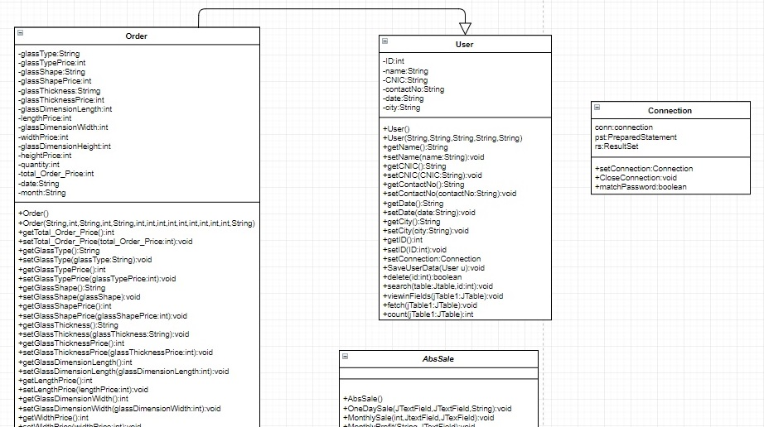**UML DIAGRAM:**

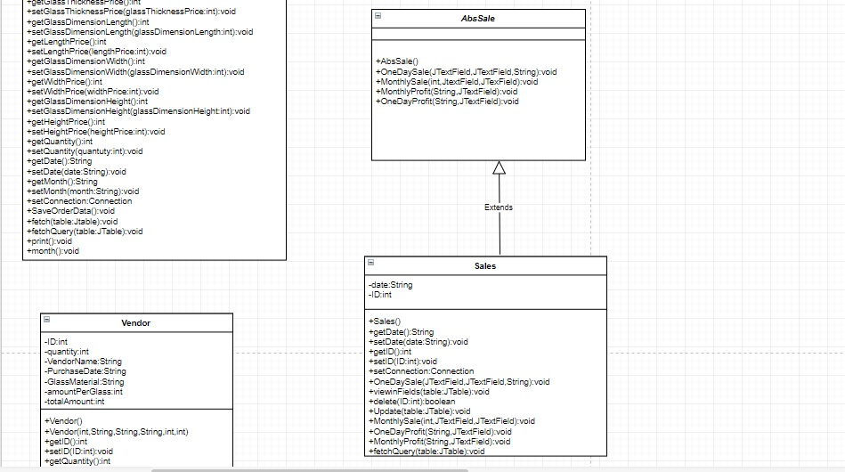

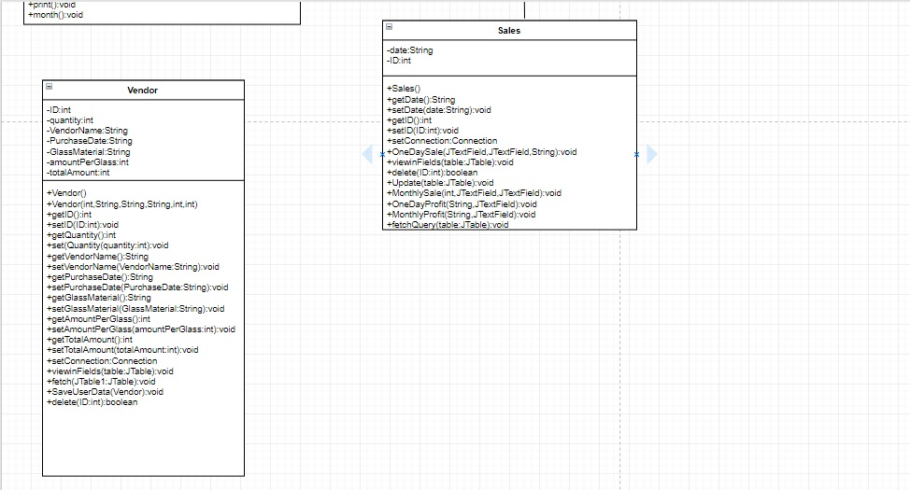

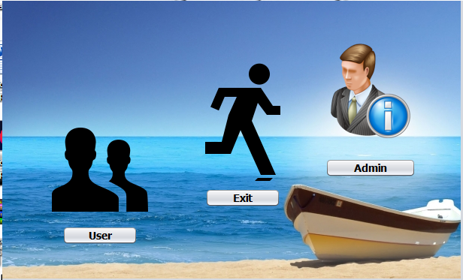**SCREEN SHOTS:**

MAIN FORM:

LOGINFORM: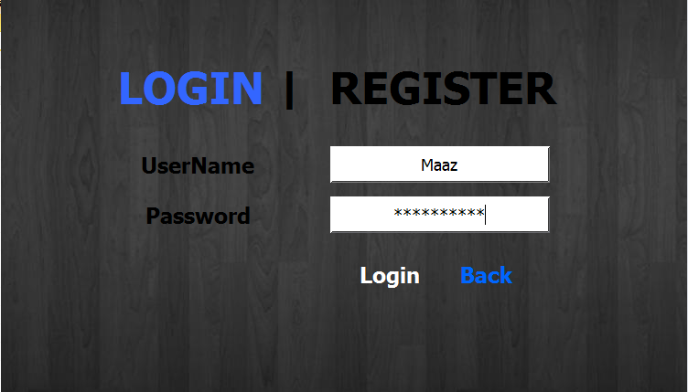

USERFORM:

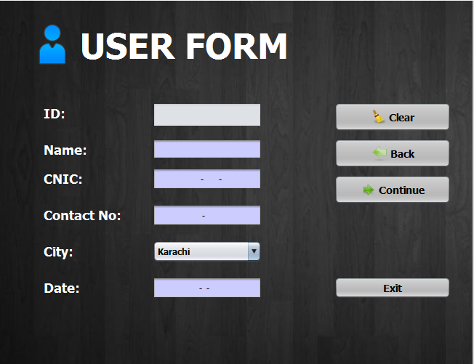

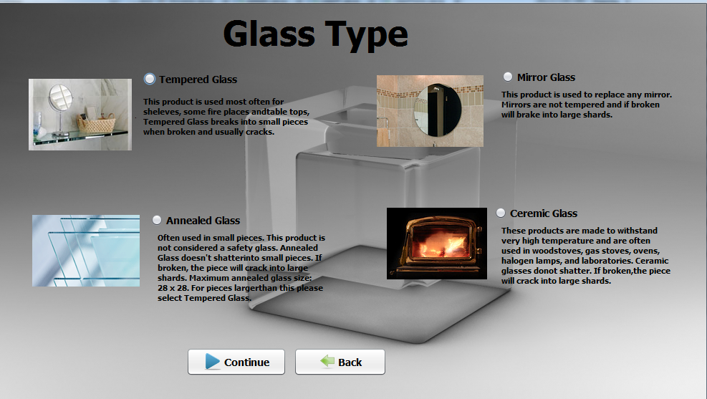GLASS TYPE FORM:

GLASS SHAPE FORM: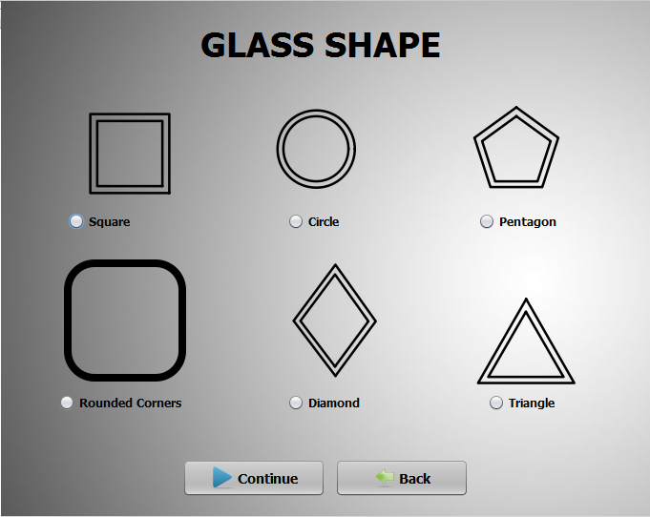

DIMENSIONS FORM: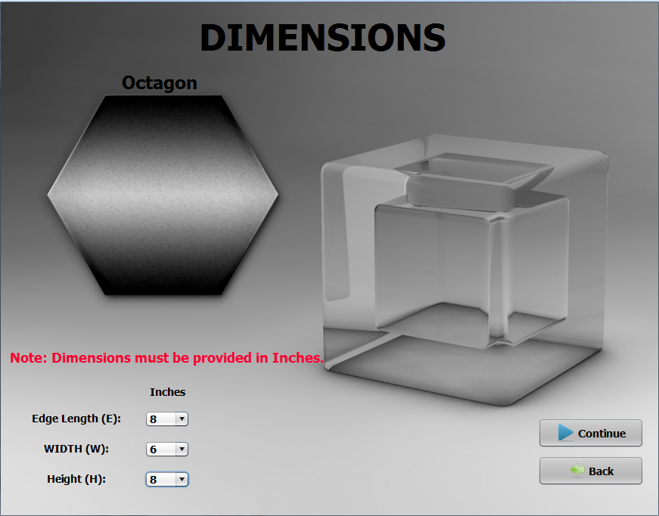

GLASS THICKNESS FORM: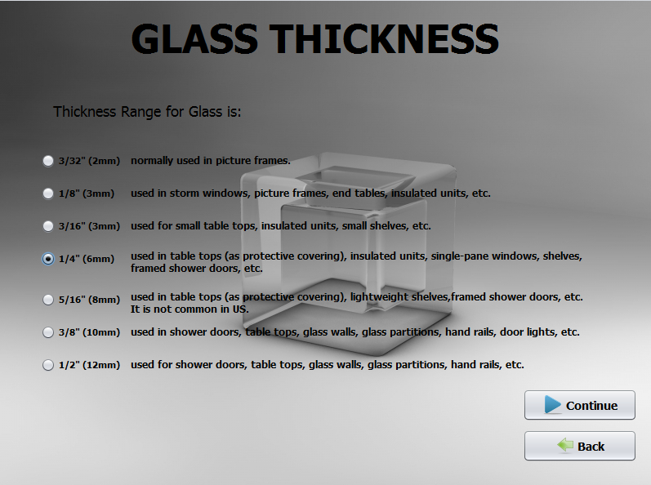PAYMENT RECEIPT FORM:

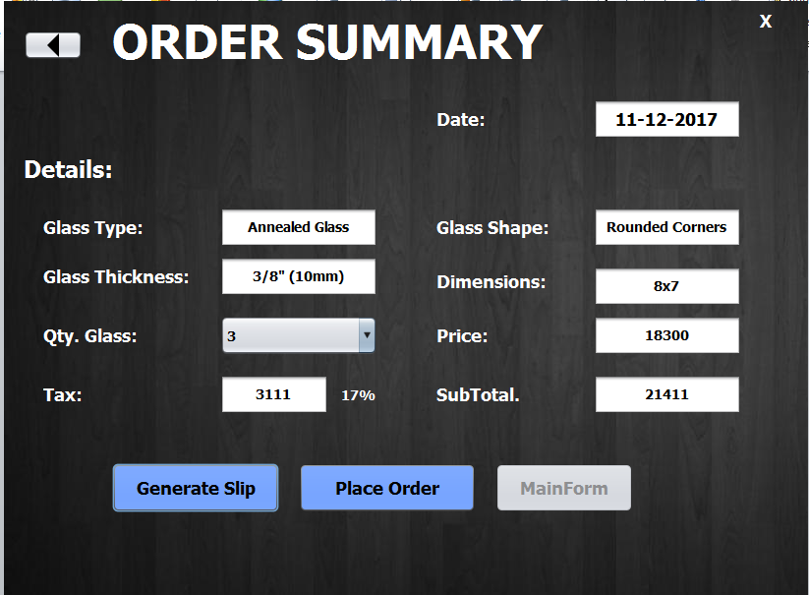

ADMIN PANEL FORM: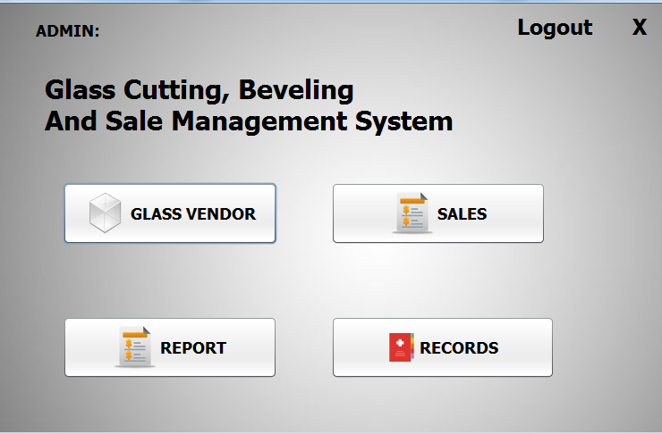

VENDOR FORM: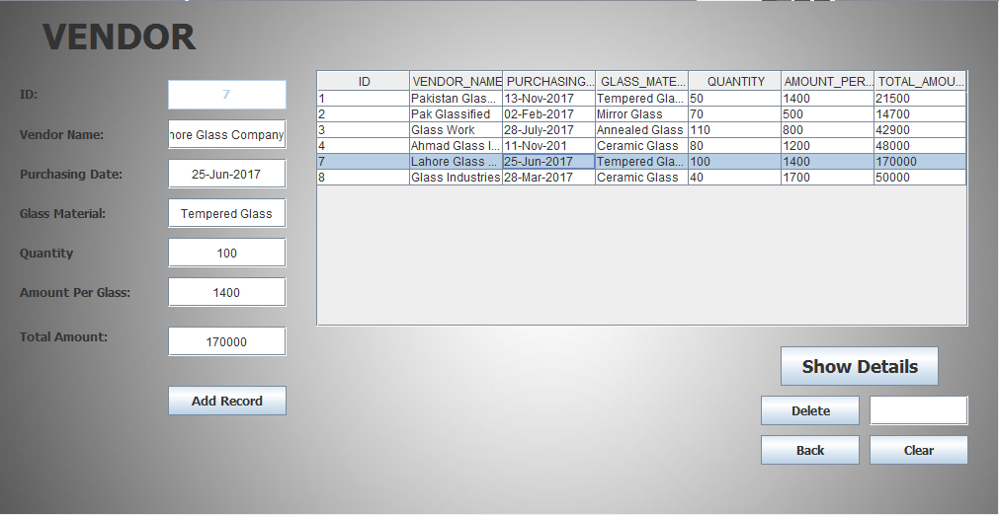

SALES FORM: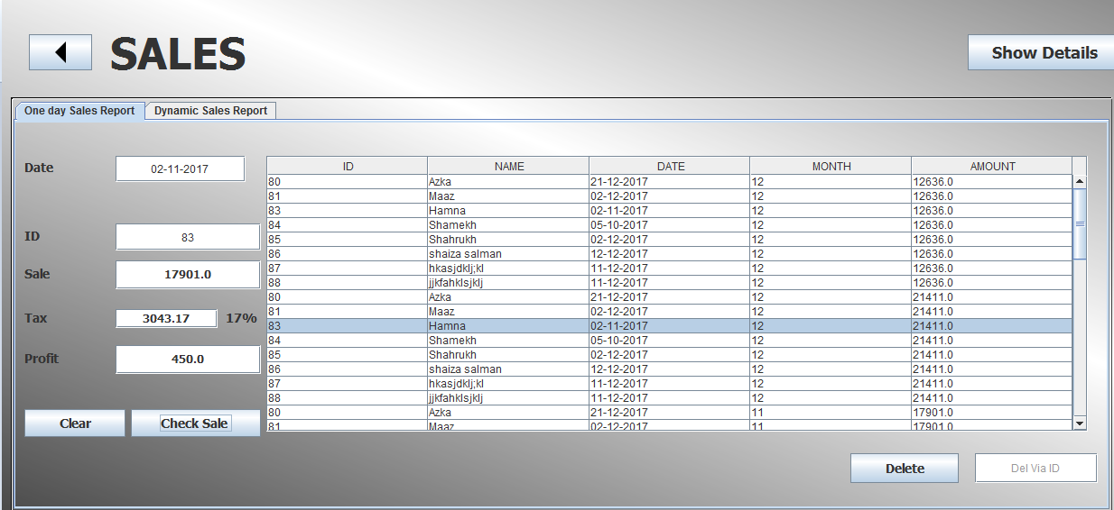

ORDER DETAILS FORM: